Department of Electrical Engineering

Faculty Member: Sir Habeel Ahmad Dated: 25-01-2026

Semester: BSCS-15 Section: D
Group No.: 17

EE-221: Digital Logic Design
Lab 1: FAM of Basic gates and ICs

 |  | PLO4/CLO4 | PLO4/CLO4 | PLO5/CLO5 | PLO8/CLO6 | PLO9/CLO7
Name | Reg. No | Viva / Lab Performance | Analysis of data in Lab Report | Modern Tool Usage | Ethics and Safety | Individual and Team Work | Total marks Obtained
 |  | 5 Marks | 5 Marks | 5 Marks | 5 Marks | 5 Marks | 25 Marks
Fatima Haroon | 577112
Noor Fatima | 559891
Nehdia Rizvi | 540841
Rahma Eman | 574974
Zain Ahmad Irfan | 577280

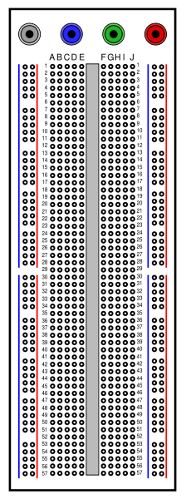

Getting Started with Circuit Patching
Breadboard:
Breadboards are usually used for patching small circuits and prototypes. A typical breadboard would look like this.

The internal connections are as shown below:
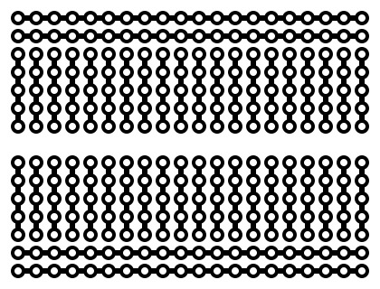

The points in ABCDE (and FGHIJ) grid are vertically connected as indicated by red circle. So all 5 points on are actually the same point. It makes No difference whether you connect a wire on any one of these points. The next vertical strip is a different point and so on.
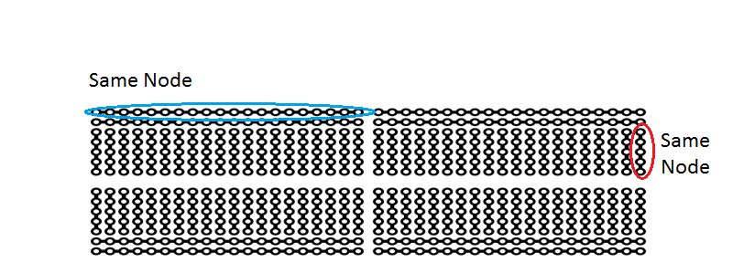
It should be noted that upper and lower grids are horizontally connected indicated below. Each grid consists of 4 such separate horizontal strips:

IC Placement on Breadboard
A typical 14 pin IC placement on such a bread board is shown below:
The upper and lower horizontal strips are normally served for power (+5V) and ground (0V) respectively. But it is not necessary to do so.
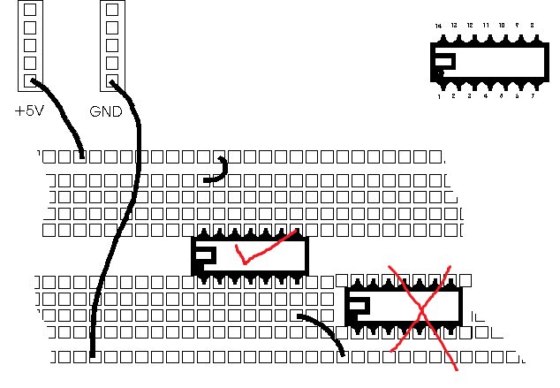

Never place any IC such that its opposite pins are within (connected to) the same Node on the same grid.
Procedure:
- Make sure the trainer board is switched off while you are patching the circuit.
- Make a neat schematic diagram clearly mentioning the IC numbers, PIN configurations and connections between different ICs.
- Place the IC(s) such that the Notch is towards the left.
- Provide the ground connection(s) by connecting the GND pin(s) of the IC(s) to 0 V on your trainer board power supply with the help of jumping wires. Make sure that all the ICs are properly grounded.
- Provide the VDD or operating voltage to each IC by connecting its VDD (or VCC) terminal to +5V on your trainer board power supply.
- Patch the circuit as per the schematic.
- Connect the inputs of your circuit to the logic switches provided on your trainer board. Typically, there are 8 such switches provided. The low position of the switch indicates a 0 logic level (0V) and the high position a logic level of 1(+5V).
- Connect the output of your circuit to the logic probe provided on the trainer board.
- Now switch on the trainer board and give the input sequence to your circuit with the help of logic switches. It is a good practice to give the input sequence in ascending order like this:
000, 001, 010, 011, 100, 101, 110, 111 (Here No. of inputs is 3).
This pattern can be adopted for lesser or more No. of inputs.
- Observe the output of your circuit against different inputs and record them in the truth table.
- Compare with theoretical values and debug the circuit if needed.
- Show your work for each lab task to your Lab Instructor.
- Give your observations and conclusion.

Lab1: Familiarization of Basic Gates and Digital ICs

This Lab Activity has been designed to familiarize the beginning students with logic gates and IC chips, using breadboard and testing of gates and logic circuits.

Objectives:

- Familiarize the students with ICs, their categories, and different logic families.
Identify ICs on the basis of series number as well as their functional behavior and pin numbers.
- Search data sheets of ICs from different sources and optimally use them in the design of digital circuits.
- Perform functional verification of basic logic gates by listing the truth tables and establishing IN/OUT relationship.
- Carry out best wiring practices in digital design.

Lab Instructions:

- This lab activity comprises three parts, namely Pre-lab, Lab tasks, and Post-lab viva session.
- The lab report will be uploaded on LMS three days before scheduled lab date. The students will get hard copy of lab report, complete the Pre-lab task before coming to the lab and deposit it with teacher/lab engineer for subsequent evaluation. Alternately each group to upload completed lab report on LMS for grading.
- The students failing to complete Pre-lab will not be allowed to attend lab session.
- The students will start lab task and demonstrate design steps separately for step-wise evaluation (teacher/lab engineer will sign each step after ascertaining functional verification). Any report submitted without teacher/lab engineer signatures will not be accepted.
- Remember that a neat logic diagram with pins numbered and nicely patched circuit will simplify trouble-shooting/fault diagnostic process.
- After completion of lab, the students are expected to unwire the circuit and deposit back components to lab staff.
- The students will complete lab task within the prescribed time and submit complete report to lab engineer before leaving the lab.
- There will be a viva session after demonstration for which students will be graded individually.

Pre-Lab Tasks: (5 marks)

- Read the topic Integrated Circuits (2.9) from your course book and answer the following questions:

Digital ICs can be categorized according to the complexity of their circuits usually termed as scale integration. The following are the six major categories. Give their full names and range of gates available in each of them.

SSI Small-Scale Integration and has between 1-10 gates per package.
MSI Medium-Scale Integration and has between 10-1,000 gates per package.
LSI Large-Scale Integration and has between 100-10,000 gate per package.
VLSI Very Large-Scale Integration and has more than 10,000 gates per package.
ULSI Ultra Large-Scale Integration and has millions of gates per package.
GSI Giant-Scale Integration and has more than 100,000 gates per package.

- Another categorization is with respect to the Logic Families of Digital ICs. The seven of these are listed below. Give their full name and give their utilization in terms of speed, power etc. (e.g. Low Power, High Speed).

RTL Resistor-Transistor Logic. Utilization is Low Speed and High Power.
DTL Diode-Transistor Logic. Utilization in Moderate Speed and Moderate Power.
ECL Emitter-Transistor Logic. Utilization is Very High Speed and Very High Power.
TTL Transistor-Transistor Logic. Utilization is High Speed and Moderate Power.
ECL Emitter-Transistor Logic. Utilization is Very High Speed and Very High Power.
CMOS Complementary Metal-Oxide Semiconductor. Utilization is High Speed and Very Low Power.
- Differentiate b/w Fan In and Fan Out of an IC.

  - Fan-In is the number of inputs available in a gate
  - Fan-Out is the total number maximum number of input gates that can be connected to the output of a single gate without affecting proper operation.

IC Pin Numbers:

TOP VIEW
Most of the ICs have a Notch (or sometimes a dot) to denote the start of the PIN numbering. Place the IC such that the Notch is on left side, then the lower left PIN is numbered 1 and the numbering continues in the anticlockwise direction.
Datasheet:
The information about any IC (its number of pins and gates inside it) can be found by simply searching by its name on internet. The document containing information about the IC is called its datasheet. Different manufacturers of these chips have this information on their sites.
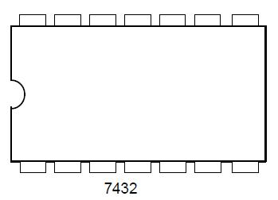
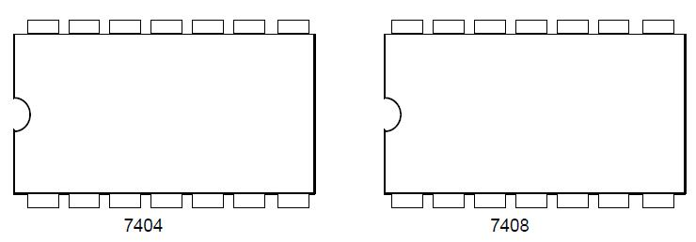
- Show the correct pin numbering and connection of gates inside these blank chips with the help of their datasheets.
- Mention the manufacturer whose datasheet you consulted.
The manufacturer whose datasheet was consulted is TEXAS INSTRUMENTS.
Lab Task (5 Marks)
Verify the functioning of the following ICs:
7408 Standard TTL 7404 Inverter Logic IC
7432 Four 2-Input Logic OR Gates
7404 Four 2-Input Logic AND Gates

Procedure
- Make a schematic layout diagram in the space provided below, showing ICs pin numbers and their connections to form the logic circuit.
- Plug in all ICs in bread board and power the ICs providing ground and VCC=5V to appropriate pins. The ground pin is to be connected first and then any other connections are made.
- By looking at pin configuration apply input signals from a switch on logic lab. Connect the output to LED for display. The operation of circuit is verified and results to be shown to teacher or Lab Asst. For trouble shooting of circuit use the logic probe provided in the lab.
- Make the truth tables in the space provided below:
- Mention the full name of each IC provided to you with the help of its datasheet and explain the naming convention (You should be able to get this information from internet).
Example: Quad 2-Input AND Gates SN74 LS08P
SN Standard Prefix of TEXAS INSTRUMENT
Quad refers to 4 AND gates
74 refers to commercial grade IC
LS means Low Power Schottky
P Plastic Dual in-Line Package
08refers to AND gate
Fill in the blanks
- The ICs in 7400 series are based on TTL logic family.
- The commercial grade IC is denoted by 74 prefix.
- The military grade IC is denoted by 54 prefix. (

Observations/Comments:
We learned proper placement of IC and their connection to switches, VCC terminal and ground to see output displayed of basic logic gates.
SN74HC08
Naming Convention:
SN: standard Prefix of TEXAS INSTRUMENT
74: refers to commercial grade IC
HC: high speed CMOS with TTL-level compatibilities
08: refers to AND gate
Schematic Layout Diagram:
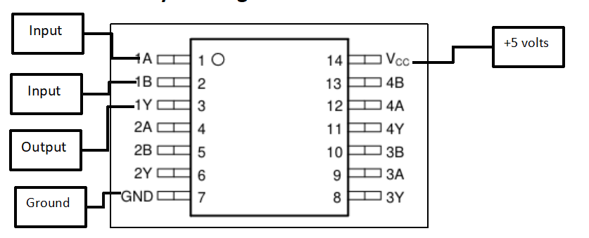
Truth Table:
1A | 1B | 1Y
1 | 1 | 1
1 | 0 | 0
0 | 1 | 0
0 | 0 | 0

Observations:
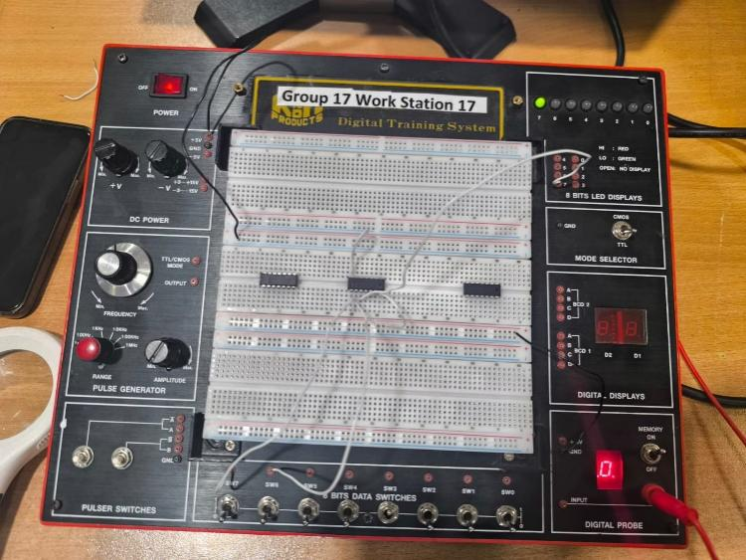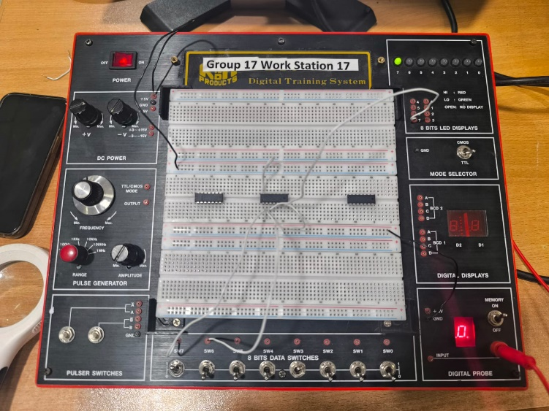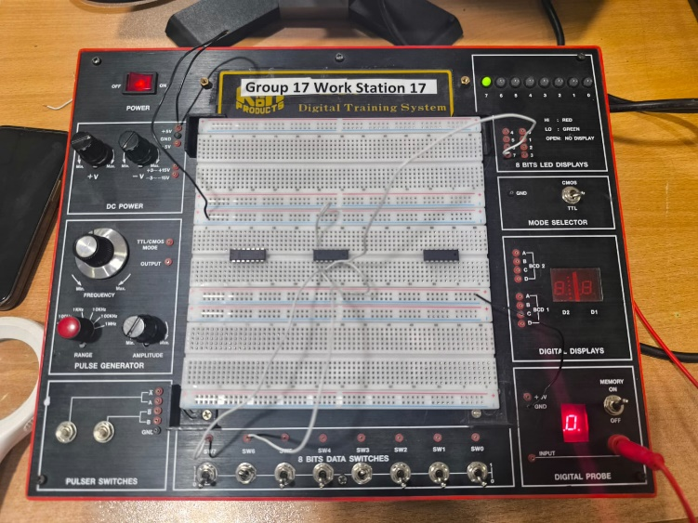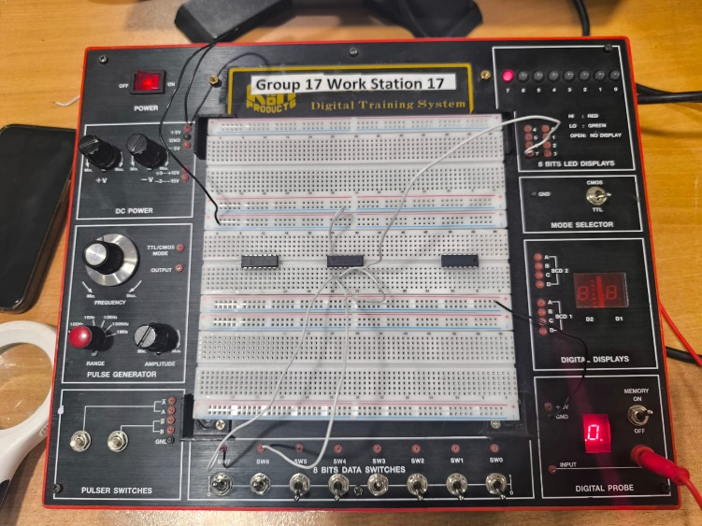
SN74HC32N
Naming Convention:
SN: standard Prefix of TEXAS INSTRUMENT
74: refers to commercial grade IC
HC: high speed CMOS with TTL-level compatibilities
32: refers to OR gate
N: package type PLASTIC DUAL INLINE PACKAGE

Schematic Layout Diagram:

Truth Table:
1A | 1B | 1Y
1 | 1 | 1
1 | 0 | 1
0 | 1 | 1
0 | 0 | 0

Observations:
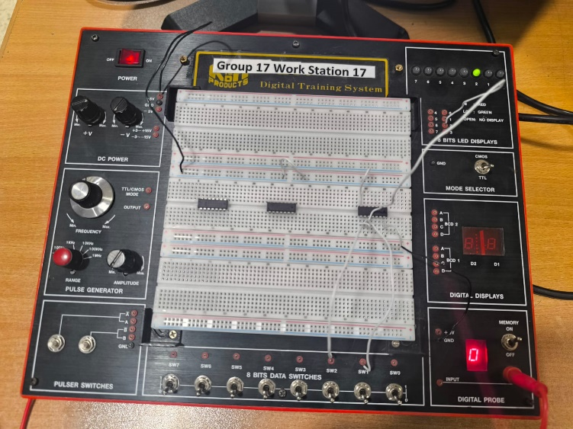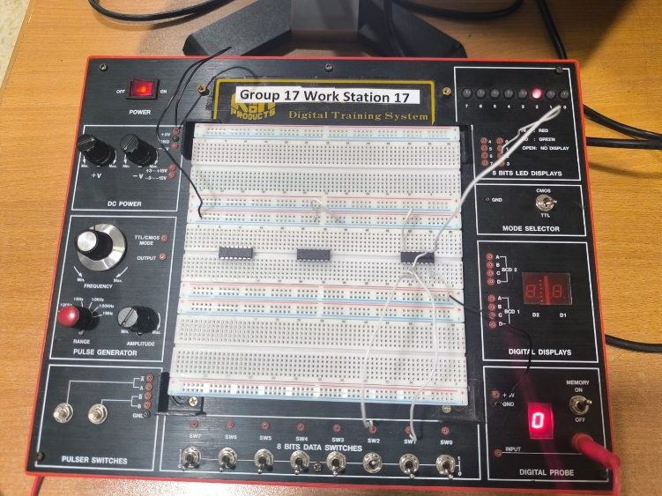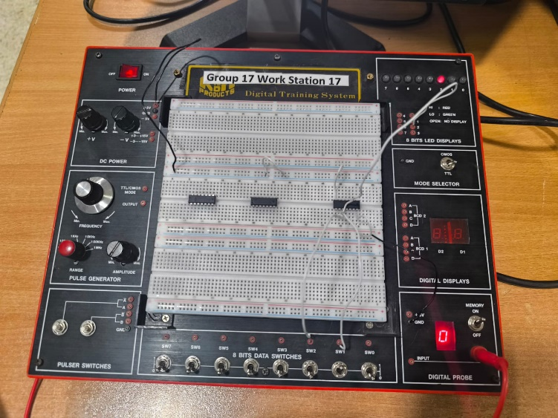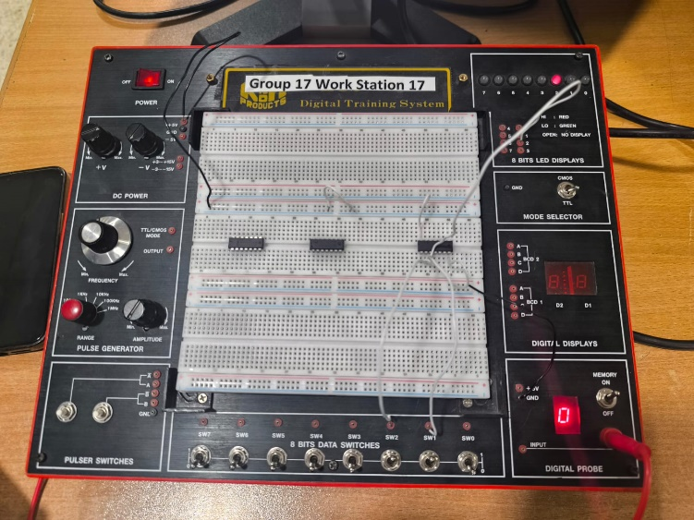
74HC04D
Naming Convention:
74: refers to commercial grade IC
HC: high speed CMOS with TTL-level compatibilities
04: refers to HEX inverter (NOT gate)
D: package type Small Outline Integrated Circuit

Schematic Layout Diagram:
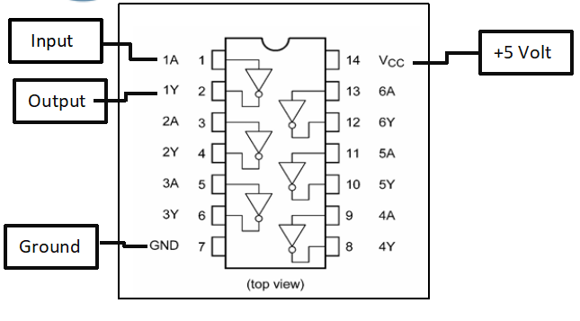
Truth Table:
1A | 1Y
1 | 0
0 | 1

Observations:
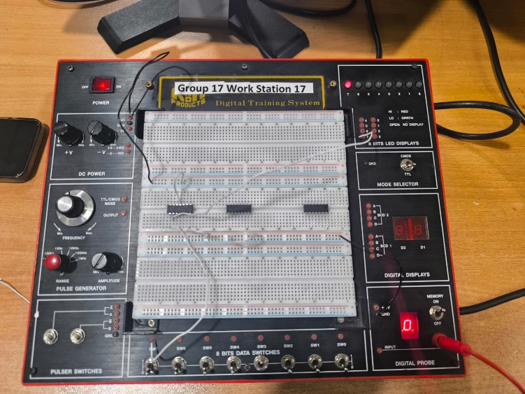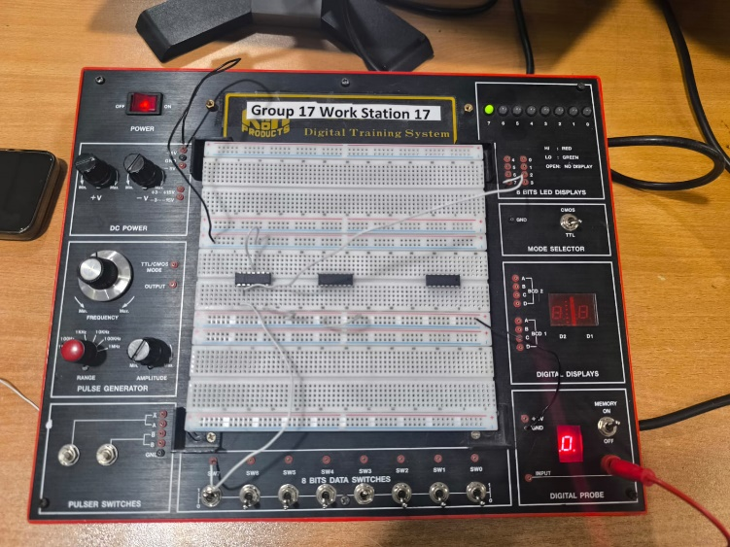
Proteus Simulation:
